Template for Evidence(s)
UI GreenMetric Questionnaire

University : ...
Country : ...
Web Address : …

[5] Transportation (TR)
SAMPLE
[5.15] Number of Transportation Initiatives to Decrease Private Vehicles on Campus

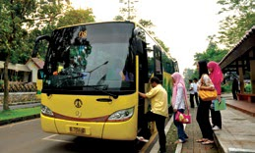 | 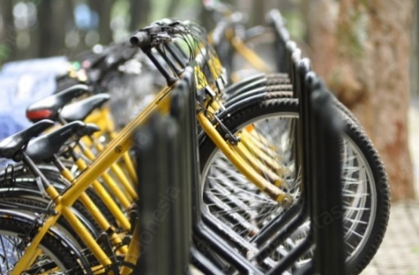
Campus Bus (Universitas Indonesia, Indonesia) | Free Bicycle for rent (Universitas Indonesia, Indonesia)

Description:
(Please describe the transportation initiatives to decrease private vehicles on campus and specify detail of data, e.g. campus bus, free bicycle, etc. The following is an example of the description. You can describe more related items if needed.)

- Shuttle/bus campus inside campus
- Free to rent bicycle on campus

Additional evidence link (i.e., for videos, more images, or other files that are not included in this file):

